Lesson 3 Enrich

Multiply Decimals by Whole Numbers

The area of a rectangle can be found by multiplying its length by its width.
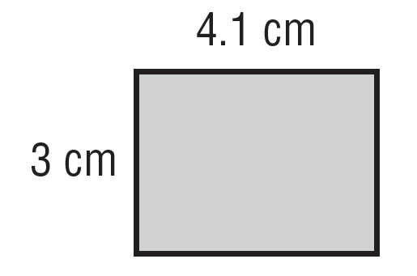
Area = length × width
Area = 3 cm × 4.1 cm
Area = 12.3 ${cm}^{2}$
The area of the rectangle is 12.3 square centimeters.

Find the area of each rectangle. Write the area inside the rectangle it measures.

