Chapter 4 Mid-Chapter STUDY GUIDE

For #1-2, estimate each product.

1. $\frac{1}{3}×20$

2. $4\frac{5}{6}×5\frac{1}{4}$

Multiply. Write in simplest form.

3. A reservoir is $5\frac{1}{3}$ miles wide. Tony sailed $\frac{5}{6}$ the width of the reservoir.
How far did Tony sail?

4.$3\frac{2}{5}×5\frac{2}{3}$

5. $\frac{3}{5}×1\frac{7}{9}$

6. $7×\frac{1}{3}$

7. $\frac{3}{7}×11$

8. $\frac{5}{6}×15$

9. MUFFINS There are 32 muffins in a bakery. If $\frac{3}{8}$ of the muffins are blueberry, how many muffins are blueberry?

10. Kenya picked 16 flowers from her garden. If $\frac{3}{5}$ of flowers in her garden remain unpicked, how many flowers are still in her garden?
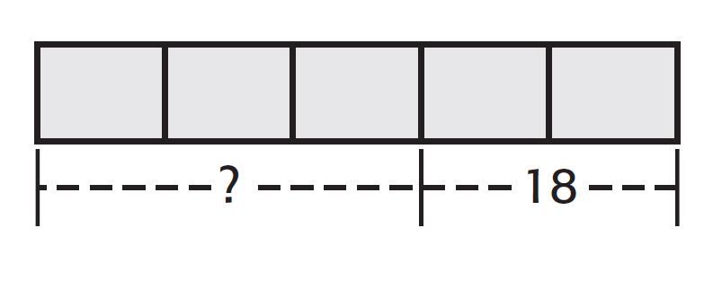

11. What is the area of a room that is $2\frac{3}{4}$ yards long by $3\frac{1}{3}$ yards wide?

Bonus: $3\frac{1}{3}$ × $2\frac{1}{2}$ × $1\frac{1}{4}$

1.___________________
1._
2. ___________________

3. ___________________

4. ___________________

5. ___________________

6. ___________________

7. ___________________

8. ___________________

9. ___________________

10. ___________________

11.___________________

Bonus: _______________

