Mid-Chapter 5 Study Guide

Write an integer for each situation.
1. a loss of 9 pounds

2. rising 19 degrees

3. 250 feet below sea level

Graph each set of integers on the number line.
4. {−1, 5, 0, −2}

5. {4, 2, -5, 1}

Evaluate each expression.
6. ⎪−14⎥

7. ⎪11⎥ − ⎪−4⎥

8. ⎪−2⎥ + ⎪8 + 2⎥

9. Michael is hiking up to a mountain top that is 987 feet above sea level. Salina scuba dived to 13 feet below sea level. What is the difference between these two measurements?

Replace each with <, >, or = to make a true statement.
10. −6 4

11. −13 −15

12. 0 −24

13. −8 −9

Order each set of integers from least to greatest.
14. 17, −26, 41, −1, 13

15. 1, −4, 29, −10, 5

Order each set of integers from least to greatest.

16. 9, −6, 2, −21, 74, −57

1. ________________________

2. ________________________

3. ________________________

4.
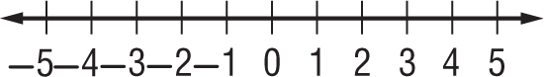

5.
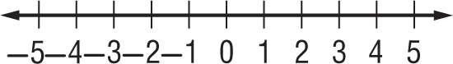

6. ________________________

7. ________________________

8. ________________________

9. ________________________

10. ________________________

11. ________________________

12. ________________________

13. ________________________

14. ________________________

15. ________________________

16. ________________________

ANSWER KEY: MID CHAPTER 5 REVIEW

Write an integer for each situation.
1. a loss of 9 pounds

2. rising 19 degrees

3. 250 feet below sea level

Graph each set of integers on the number line.
4. {−1, 5, 0, −2}

5. {4, 2, -5, 1}

Evaluate each expression.
6. ⎪−14⎥

7. ⎪11⎥ − ⎪−4⎥

8. ⎪−2⎥ + ⎪8 + 2⎥

9. Michael is hiking up to a mountain top that is 987 feet above sea level. Salina scuba dived to 13 feet below sea level. What is the difference between these two measurements?

Replace each with <, >, or = to make a true statement.
10. −6 4

11. 13 −15

12. 0 −24

13. 8 −9

Order each set of integers from least to greatest.
14. 17, −26, 41, −1, 13

15. 1, −4, 29, −10, 5

16. 9, −6, 2, −21, 74, −57

1. _________-9_____________

2. _______19_______________

3. _________-250_____________

4.

5.

6. _________14______________

7. __________7______________

8. _________12______________

9. __________1000 ft._________

10. __________<_____________

11. __________>_____________

12. ___________>____________

13. ___________>____________

14. __-26, -1, 13, 17, 41_______

15. ___-10, -4, 1, 5, 29________

16. ___-57, -21, -6, 2, 9, 74_____

