Chapter 1 - Ratios and Proportional Reasoning [346697]
Student
Class
Date

1. | A bag of chips holds 28 ½ ounces. One serving is 3/4 of an ounce. About how many servings are in the bag?

2. | Franco read 5/8 of a chapter of his history book in 1/6 of an hour. At this rate, how many chapters of his history book can he read in 1 hour?

3. | Jamal runs for a track team. He ran 2$\frac{3}{10}$ miles in $\frac{1}{4}$ of an hour. What was Jamal’s rate of speed?

4. | Janelle types at the rate of $\frac{5}{8}$ of a page per minute. Which statement about Janelle is true?
 | A. Janelle can type 8 pages in 5 minutes.
 | B. Janelle can type $\frac{5}{12}$ of a page in of a minute.
 | C. Janelle can type 1$\frac{1}{5}$ of a page in of a minute.
D.
Janelle can type $\frac{5}{6}$ pages in of a minute.

5. | Doug drove 205$\frac{1}{3}$ miles in 3.5 hours. How many miles did Doug average per hour?

6. | At a gas station, Lora took $\frac{1}{8}$ minute to fill $\frac{7}{10}$ gallon of gas. At this rate, how many gallons of gas could Lora fill in 1 minute? Use a mixed number to express your answer.

7. | Which two quantities form a proportional relationship?
 | A. $\frac{2}{5}= \frac{2}{20}$
 | B. $\frac{4}{25}= \frac{6}{50}$
 | C. $\frac{3}{4}= \frac{5}{8}$
 | D. $\frac{10}{16}=\frac{35}{56}$

8. | Name 2 characteristics of a graph that shows a proportional relationship between x and y. Draw an example of this graph.

9. | Dante bought 12 pounds of metal for $30. Which purchase would have the same cost per pound as Dante’s purchase?
 | A. 5 pounds of metal for $12
 | B. 6 pounds of metal for $16
 | C. 18 pounds of metal for $40
 | D. 2 pounds of metal for $6

10. | Look at point S in the coordinate grid below.  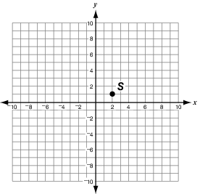  If a line contains both point S and the origin, which point(s) would the line also contain? Why?
 | A. (16, 8)
 | B. (12, 7)
 | C. (15, 8)
 | D. (18, 9)

11. | Albert wants to buys some pens. He is comparing 2 different packs of pens. The number of pens in each pack and the cost of the pack is shown in the table below.  $4.56 for 9 pens or $3.25 for 6 pens  How much does 1 pen cost in each pack? Which pack is the better buy (cheaper per pen)?

12. | Isabelle’s school has a total of 448 seventh grade students. There are 2 technology classes, each with 28 seventh grade students. What is the ratio of seventh grade students taking a technology class to all seventh grade students?
 | A. 14:1
 | B. 1:14
 | C. 8:1
 | D. 1:8

13. | Mike bought 6.5 pounds of bananas for $5.46. What is the price per pound for the bananas?

14. | Mario created a table to help him graph the total distance, d, that he will walk in t days.  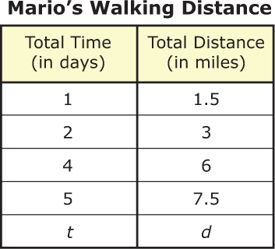  Write an explanation that best describes what the ordered pair (1, 1.5) in the table means.

15. | The graph below shows how the number of pages Jeff reads is related to the number of hours he spends reading.  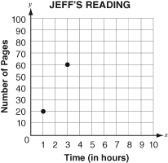  If Jeff continues to read at the same rate as shown in the graph, how many hours would it take him to read 70 pages?

16. | Peter drew the graph below to show how the number minutes he runs depends on the number of laps he runs around the track.  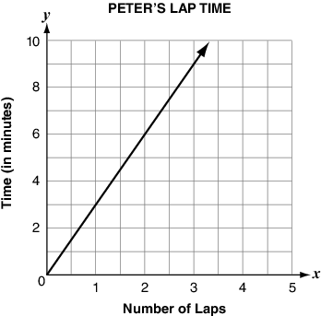  How many minutes does it take Peter to run 1 lap? 2 laps? 3 laps?

17. | The number of necklaces Jane makes is proportional to the time (in days) she takes to make them. This relationship is graphed below.  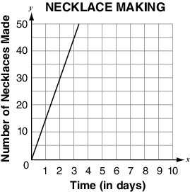  Write the ordered pair that indicates the unit rate in terms of necklaces per day.

18. | The graph below shows the amount of sugar required to make different-sized batches of cookies.  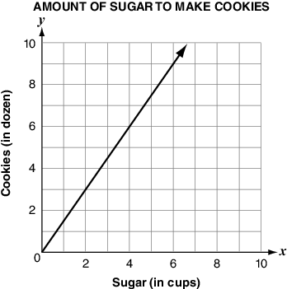  What does point (4,6) represent in terms of the number of cookies and the cups of sugar?

19. | A company surveyed 300 people.  - 140 people preferred the taste of soft drink X.  - 90 people preferred the taste of soft drink Y.  - 70 people preferred the taste of soft drink Z.  - The company plans to produce 1 million bottles of soft drink.  Based on the results of the survey, about how many bottles of soft drink Y should the company produce?

20. | A car is traveling at 65 miles per hour, how many feet per minute is it traveling?

21. | A fox can run at a speed of 44 miles per hour. How many feet per second is this?

22. | Solve for x.  $\frac{33}{11}= \frac{x}{14}$

23. | What is the slope of the line?  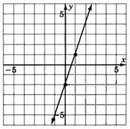

24. | Use the graph below to answer the questions.  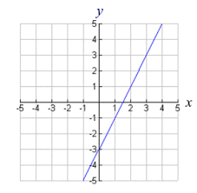
 | A. Does the graph show a proportional relationship?
 | B. What is the slope of this line?
 | C. Does the graph have a positive or negative slope?

25. | Selena babysits on the weekends. The equation y=8x represents the amount of money she earns. What is the constant of proportionality? Explain what this represents.

